->First when I started to clone my repository from github.

From vs code by logging into github account

->And then I start making folders inside JAVA_CODE_Q-A_WITH-_EVERY_TOPIC folder

Which is a name of my repository.

->After that I make java file:- “IntroductionInDP” in the folder:- “41. DP (Part1)”

And the terminal open :- but it would not open the folder where the java file is store

* When I try to run java class file IntroductionInDP.
* It throw error class do not find
* So it need to run cd cmd to open the exact location of file in which exist in the folder

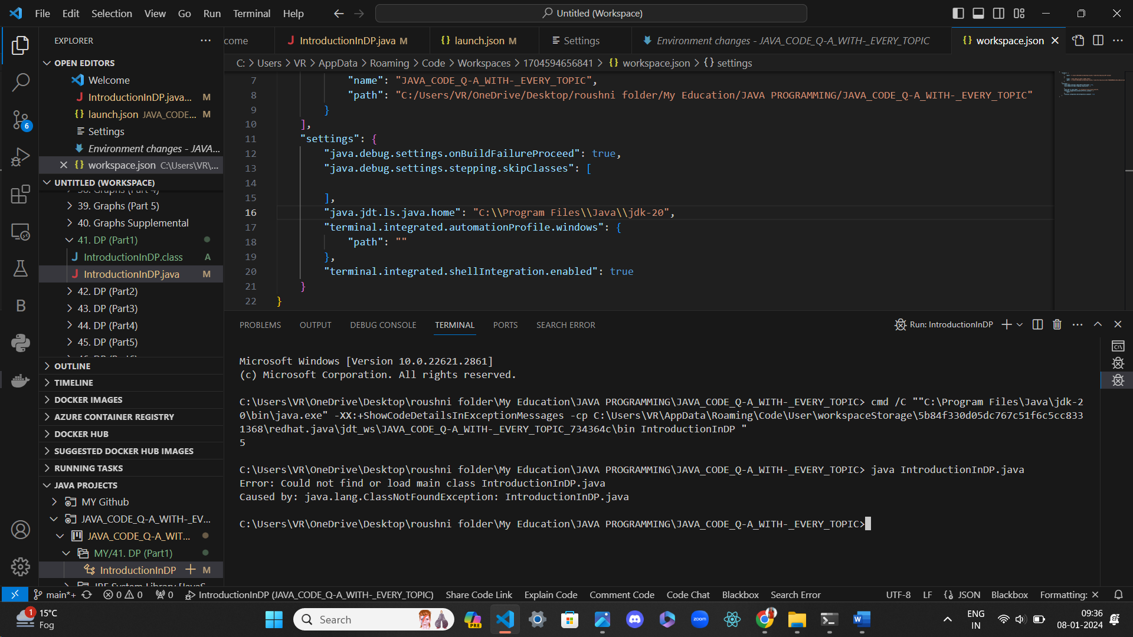

* After that I copied the path of folder

C:\Users\VR\OneDrive\Desktop\roushni folder\My Education\JAVA PROGRAMMING\JAVA_CODE_Q-A_WITH-_EVERY_TOPIC\MY\41. DP (Part1)

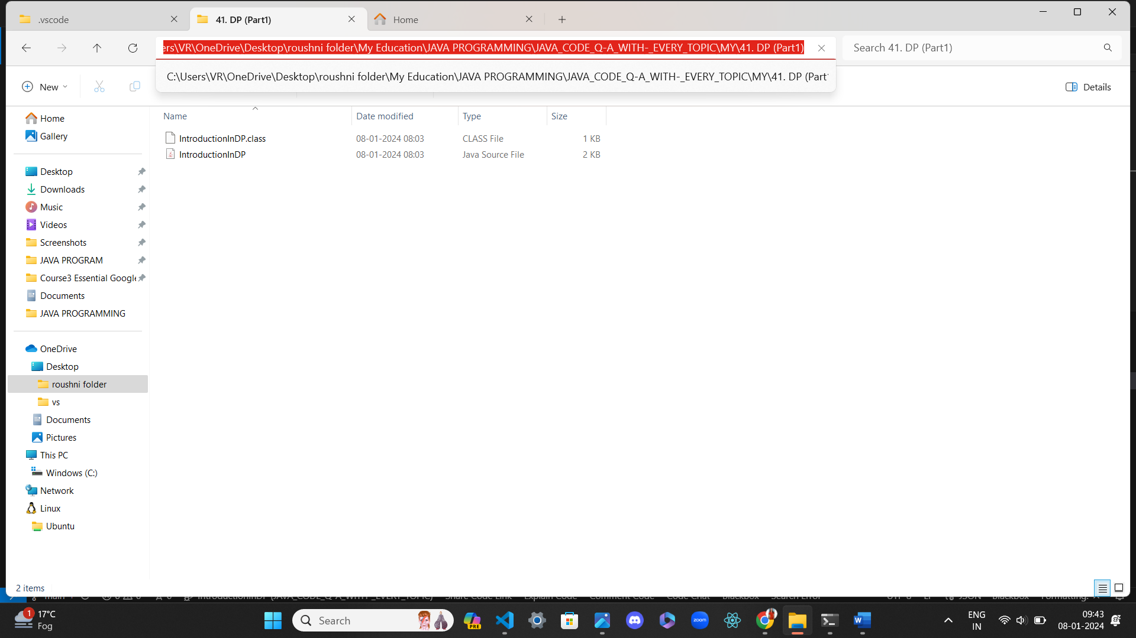

* After that I write the cd cmd in terminal to change the directory
* cd C:\Users\VR\OneDrive\Desktop\roushni folder\My Education\JAVA PROGRAMMING\JAVA_CODE_Q-A_WITH-_EVERY_TOPIC\MY\41. DP (Part1)
* it change the directory

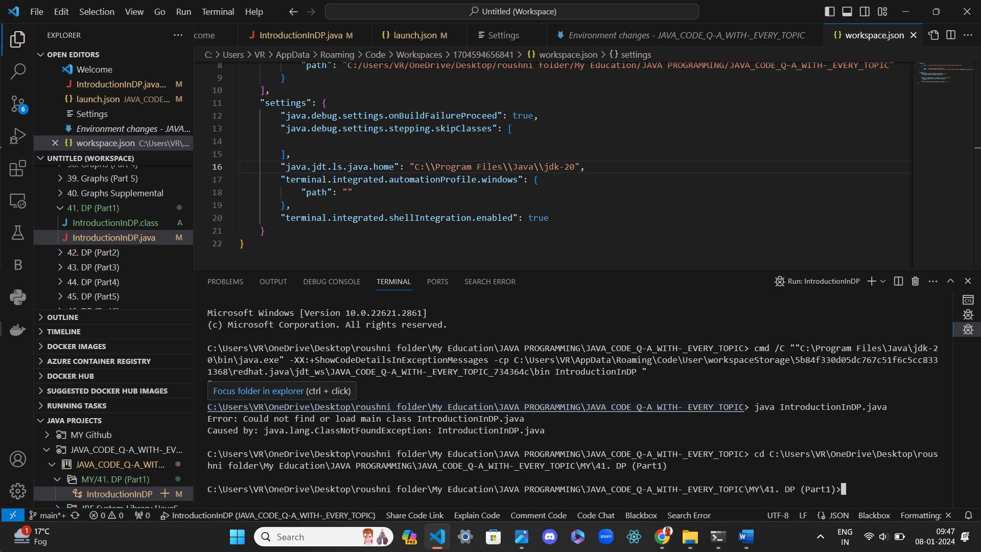

* so now I can run the java file by first comile the IntroductionInDP.java by
* writing:- javac IntroductionInDP.java
* now we run the file by writing :- java IntroductionInDP.java

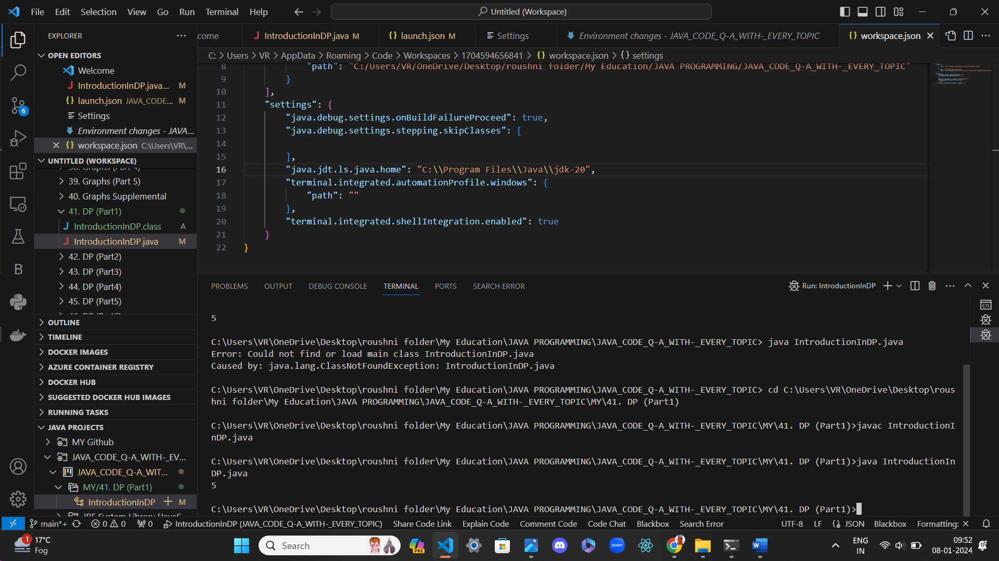

First thing I can run my file from two ways

->first from the cmd line ->Second from clicking on the Run and Debug icon of the Visual studion code

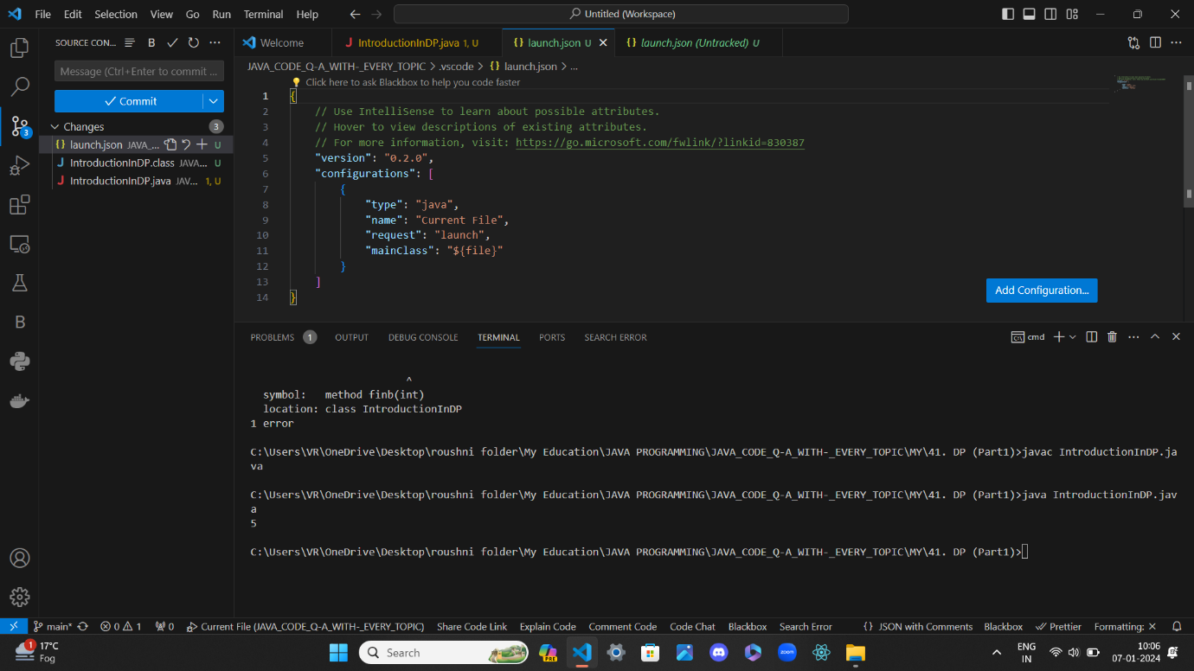

First to note this workspace is not under any project so that java debug extension and run inside the JRE

Is not possible hence the run or debug icon was not working so there was existing project so I add the workspace to the project JAVA Programming and it has jre , jdk to run java file but there is two error

* first was it cannot able to find java bin so that it has address to run

so to solve this I have two JDK of two version jdk17 and JDK20

so I set the path in Environmental variable and in VS CODE I change the path in Setting .json

and in the Launch.json file

launch.json help to compile all the file that saved under the folder JAVA_CODE_Q-A_WITH-_EVERY_TOPIC\MY by adding the name, path , project of the file in the configuration not only that what configuration launch I add

"version": "0.2.0",

    "configurations": [

        {

            "type": "java",

            "name": "IntroductionInDP",

            "request": "launch",

            "mainClass": "IntroductionInDP",

            "projectName": "JAVA_CODE_Q-A_WITH-_EVERY_TOPIC_734364c"

        },

And here second thing to note that projectName was empty it was also throwing error

When all thing was running i.e I solved all the problem which I say in the below one error was left about the project Name in configuration of Launch .json

So in the"projectName": First I add file name “IntroductionInDP” and there later I added ‘MY Github’ so I thought is the above all the folder it may be project but I was wrong the project name in config in launch json file was name is "projectName": "JAVA_CODE_Q-A_WITH-_EVERY_TOPIC_734364c"

And how I get the correct project Name by kepping that option empty "projectName" and when I run the file then it asked

To select the project:” JAVA_CODE_Q-A_WITH-_EVERY_TOPIC_734364c” for the IntroductionInDP file

Even right now removing the project name every thing is working okay I will talk this later now

So after setting the environmental variable I add the in the setting json the java bin address because it cannot able to locate bin to execute the java file and I change launch json file , and setting json file

{

    // Use IntelliSense to learn about possible attributes.

    // Hover to view descriptions of existing attributes.

    // For more information, visit: https://go.microsoft.com/fwlink/?linkid=830387

    "version": "0.2.0",

    "configurations": [

        {

            "type": "java",

            "name": "IntroductionInDP",

            "request": "launch",

            "mainClass": "IntroductionInDP",

            "projectName": "JAVA_CODE_Q-A_WITH-_EVERY_TOPIC_734364c"

        },

        {

            "type": "java",

            "name": "IntroductionInDP",

            "request": "launch",

            "mainClass": "IntroductionInDP",

            "projectName": "JAVA_CODE_Q-A_WITH-_EVERY_TOPIC"

        },

        {

            "type": "java",

            "name": "Launch Current File",

            "request": "launch",

            "mainClass": "${file}",

            "console": "integratedTerminal"

        }

    ],

    "java.configuration.runtimes":

        [

            {

                "name": "JavaSE-20",

                "path": "C://Program Files/Java/jdk-20\bin",

            },

        ],

}

Which look like

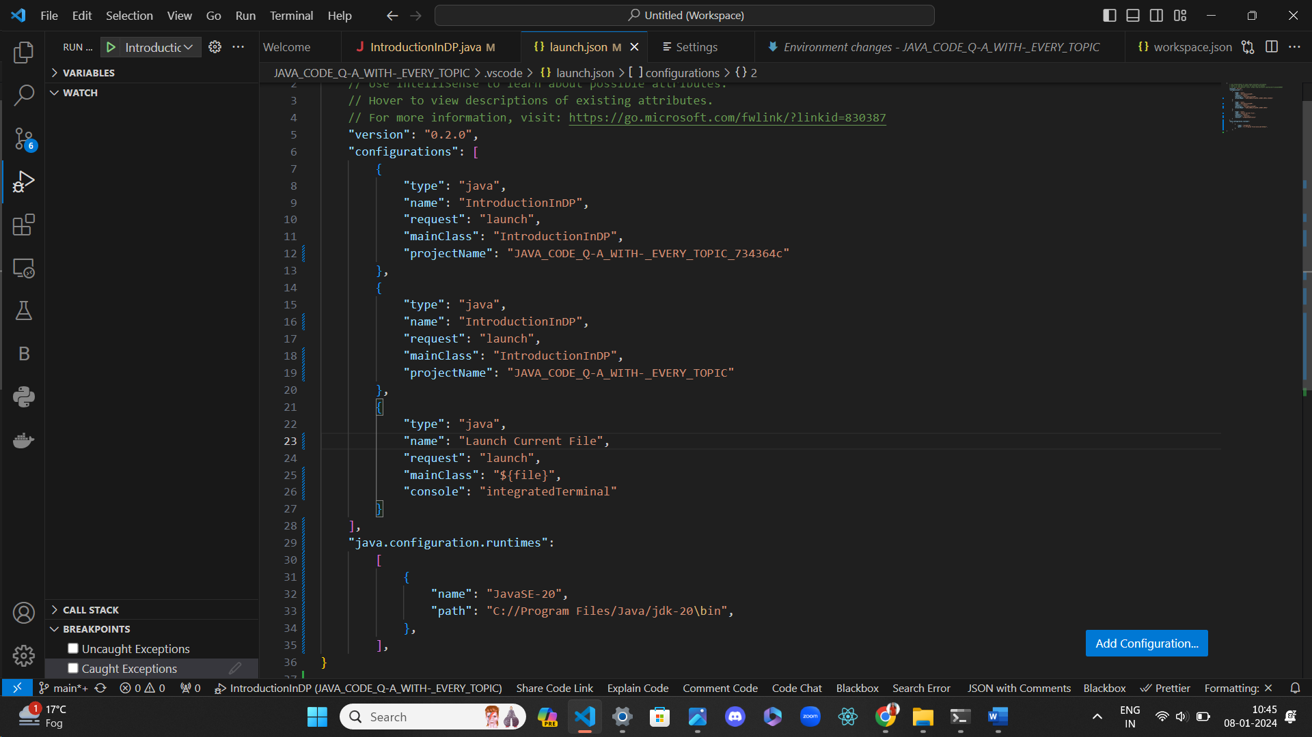

And I made changes in the setting json file:- which is vscode folder file here vscode is the part of the project:- "JAVA_CODE_Q-A_WITH-_EVERY_TOPIC_734364c"

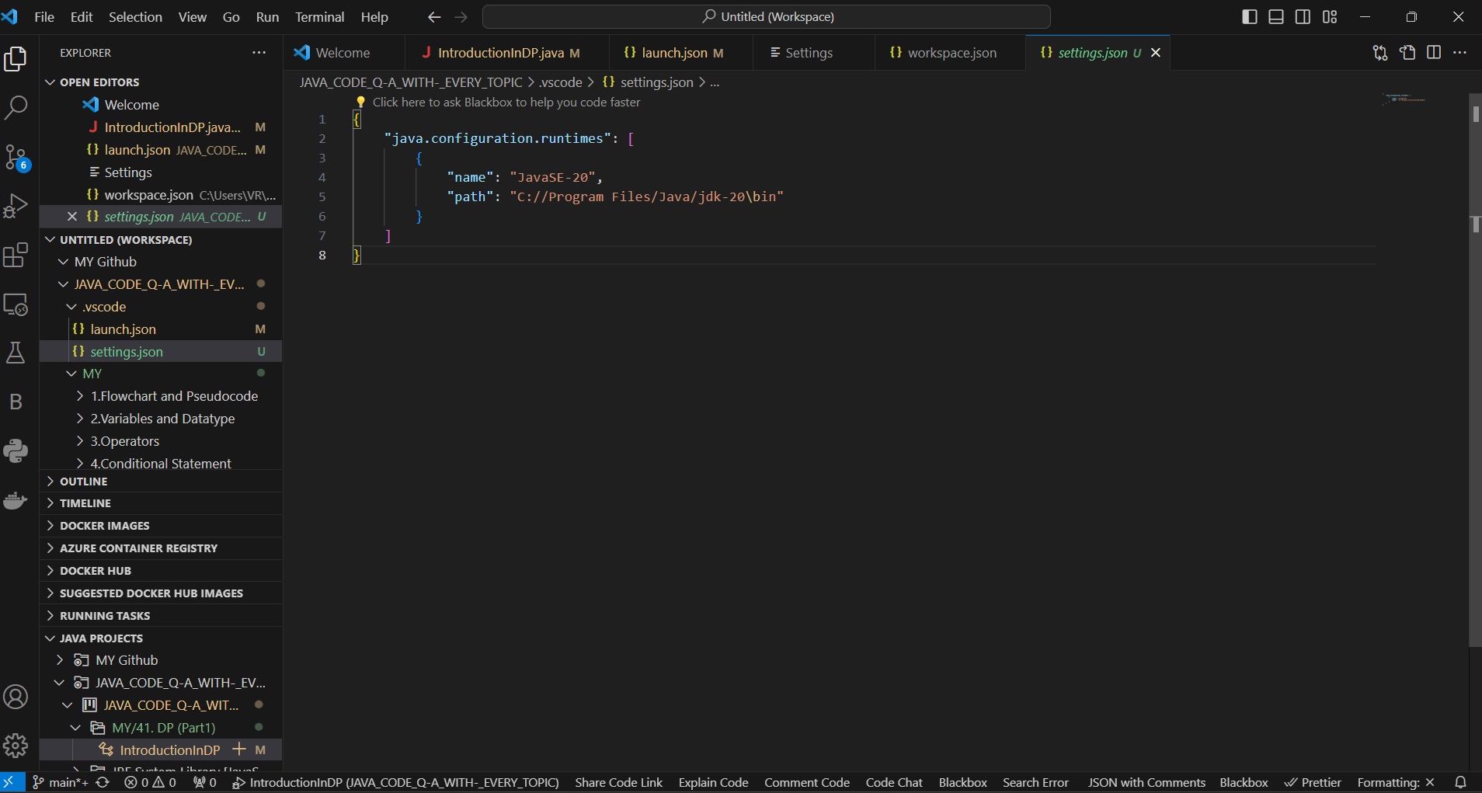

{

    "java.configuration.runtimes": [

        {

            "name": "JavaSE-20",

            "path": "C://Program Files/Java/jdk-20\bin"

        }

    ]

}

And I also made changes in user setting.json after making the environmental variable all I have done adding java configuration runtime

 "java.configuration.runtimes": [

        {

            "name": "JavaSE-17",

            "path": "C://Program Files/Java/jdk-17",

        },

        {"name": "JavaSE-20",

        "path": "C://Program Files/Java/jdk-20"}

So in the previous project I had added more configuration in setting.json of user

 "security.workspace.trust.untrustedFiles": "open",

    "files.autoSave": "afterDelay",

    "codestream.serverUrl": "https://codestream-us1.service.newrelic.com",

    "redhat.telemetry.enabled": true,

    "C_Cpp.codeAnalysis.exclude": {

    },

    "C_Cpp.autocompleteAddParentheses": true,

    "java.codeGeneration.generateComments": true,

    "java.completion.lazyResolveTextEdit.enabled": false,

    "java.configuration.runtimes": [

        {

            "name": "JavaSE-17",

            "path": "C://Program Files/Java/jdk-17",

        },

        {"name": "JavaSE-20",

        "path": "C://Program Files/Java/jdk-20"}

    ]

    ,

    "java.import.gradle.java.home": "",

    "terminal.integrated.sendKeybindingsToShell": true,

    "terminal.integrated.defaultProfile.windows": "Command Prompt",

    "terminal.integrated.automationProfile.windows": {

        "path": "/bin/bash",

    },

    "settingsSync.ignoredExtensions": [

        "dbaeumer.jshint"

    ],

    "workbench.settings.applyToAllProfiles": [

        "aurahelper.metadata.scanCategories"

    ],

    "aurahelper.metadata.scanCategories": [

        "Design",

        "Best Practices",

        "Security",

        "Performance",

        "Code Style"

    ],

Note

This change was necessary and it done in before project work of java.

So it look like:-

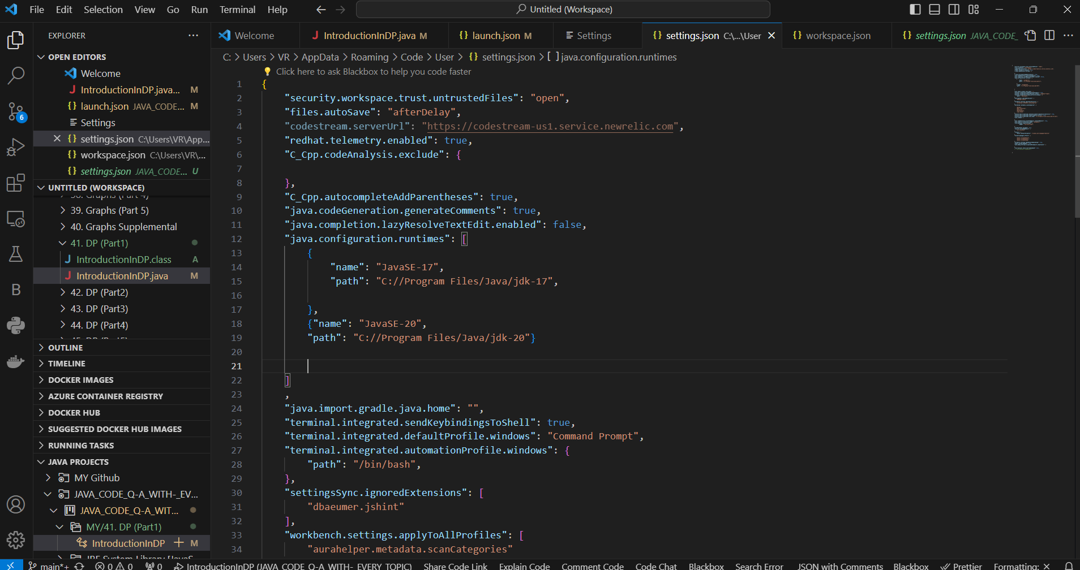

And I also made changes in the Workspace .json file which is of the folder JAVA_CODE_Q-A_WITH-_EVERY_TOPIC

In this I first in debug setting I enable the option that is shown in written form in the workspace json

Then I locate java home path

{

    "folders": [

        {

            "path": "C:/Users/VR/OneDrive/Desktop/roushni folder/My Education/MY Github"

        },

        {

            "name": "JAVA_CODE_Q-A_WITH-_EVERY_TOPIC",

            "path": "C:/Users/VR/OneDrive/Desktop/roushni folder/My Education/JAVA PROGRAMMING/JAVA_CODE_Q-A_WITH-_EVERY_TOPIC"

        }

    ],

    "settings": {

        "java.debug.settings.onBuildFailureProceed": true,

        "java.debug.settings.stepping.skipClasses": [

        ],

        "java.jdt.ls.java.home": "C:\\Program Files\\Java\\jdk-20",

        "terminal.integrated.automationProfile.windows": {

            "path": ""

        },

        "terminal.integrated.shellIntegration.enabled": true

    }

}

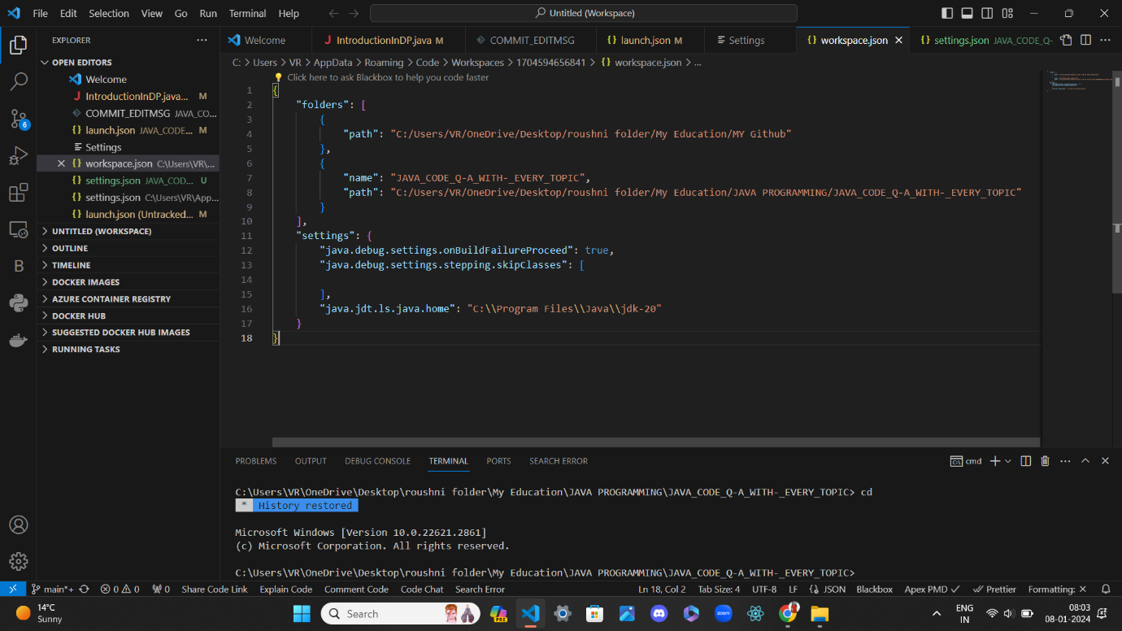

Note after adding this in WorkSpace

"java.jdt.ls.java.home": "C:\\Program Files\\Java\\jdk-20",

this is mainly help the launch json file only after adding bin java path in the Lunch.json file

And after that error not solve and by clicking the debug the file it throw error

So hence now only 1 error left which is debug is not working which is all done ine vscode setting terminal integration checkbox function apply option where I check one function it automatically its above one function which I guess it creating error.

So in depth below step is given how I tackle debug problem step by step after running to debug the IntroductionInDP.java file

First it always throw the error that:-

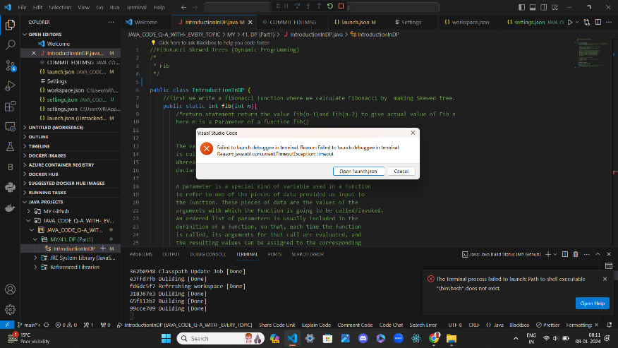

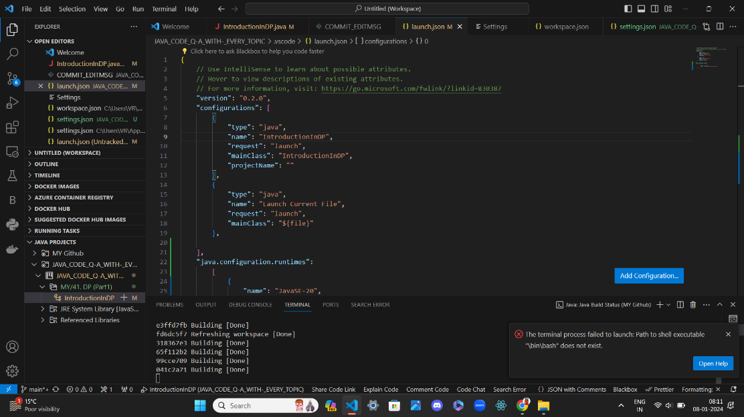

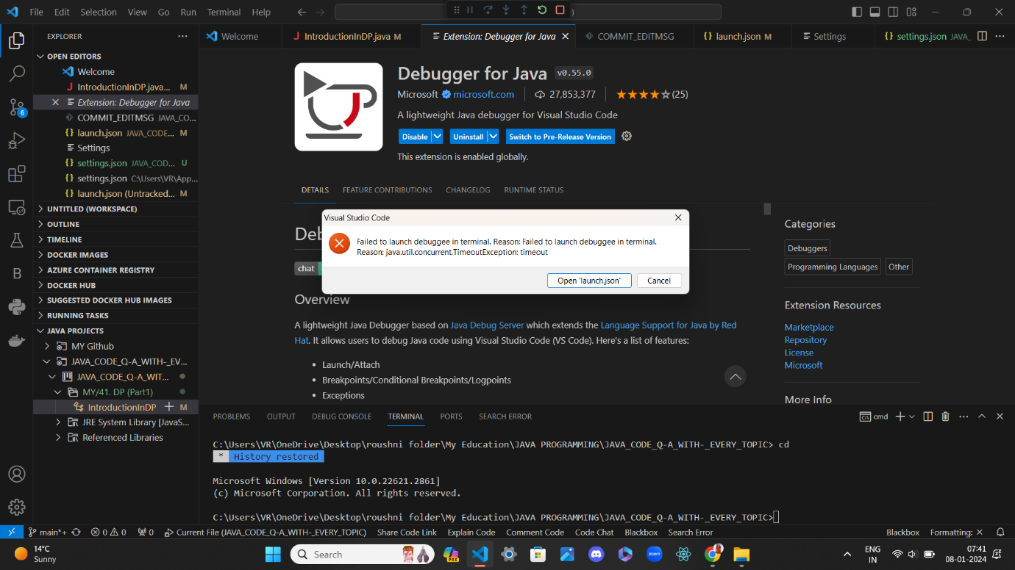

I was clicking in the “open help” button and also “OPEN launch json” button but I cannot able to figure out I study how to run java debug by installing extension java debugger and java jdk and I all study in the onle VS STUDIO Online help community document but I cannot figure out

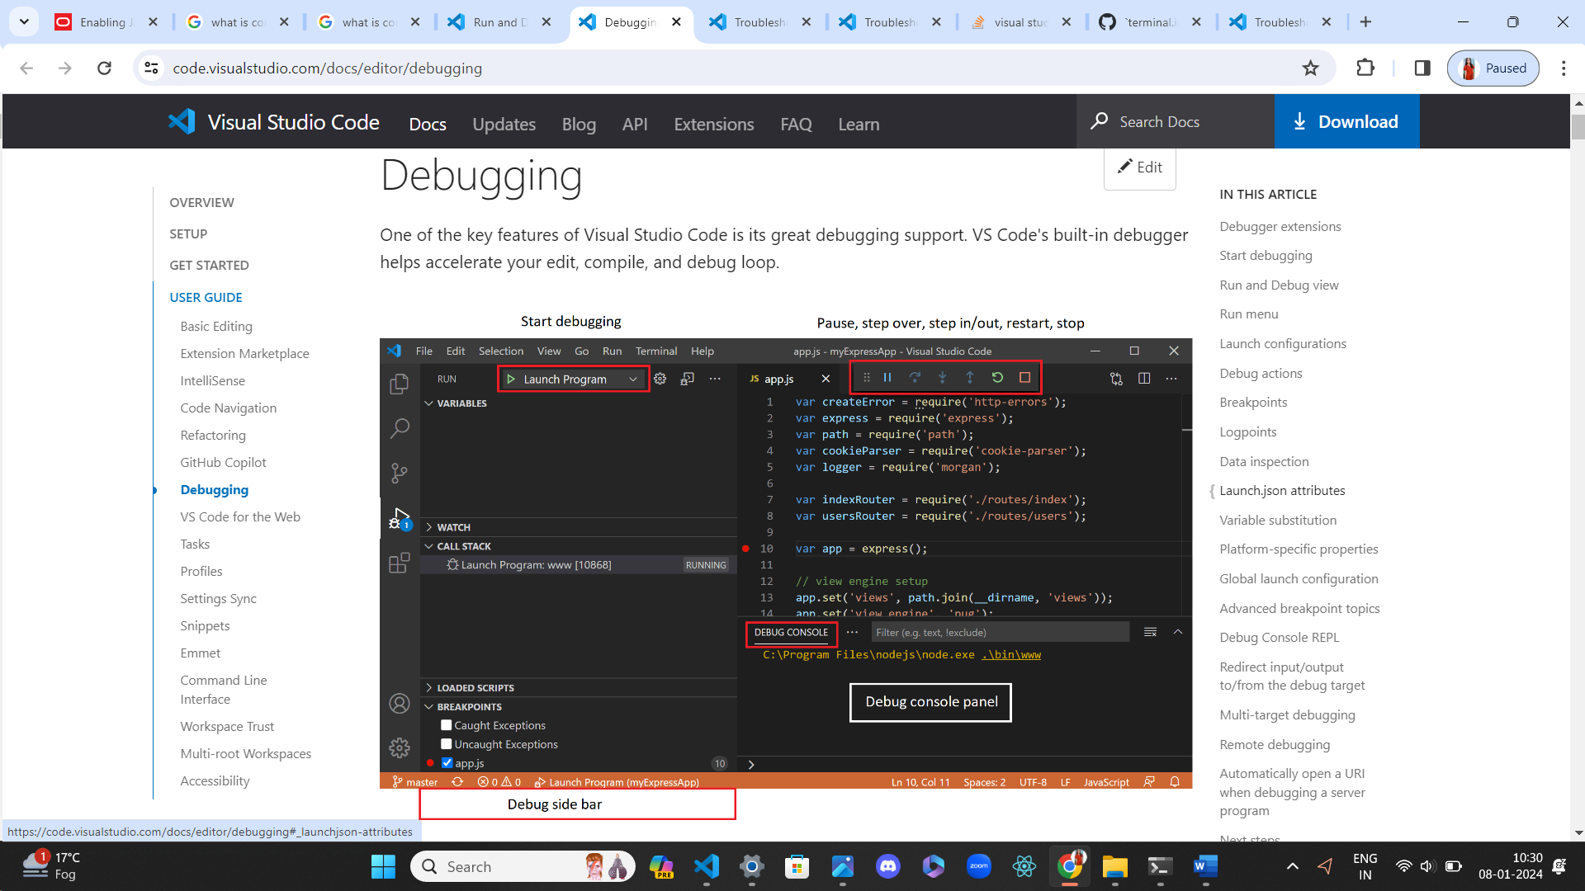

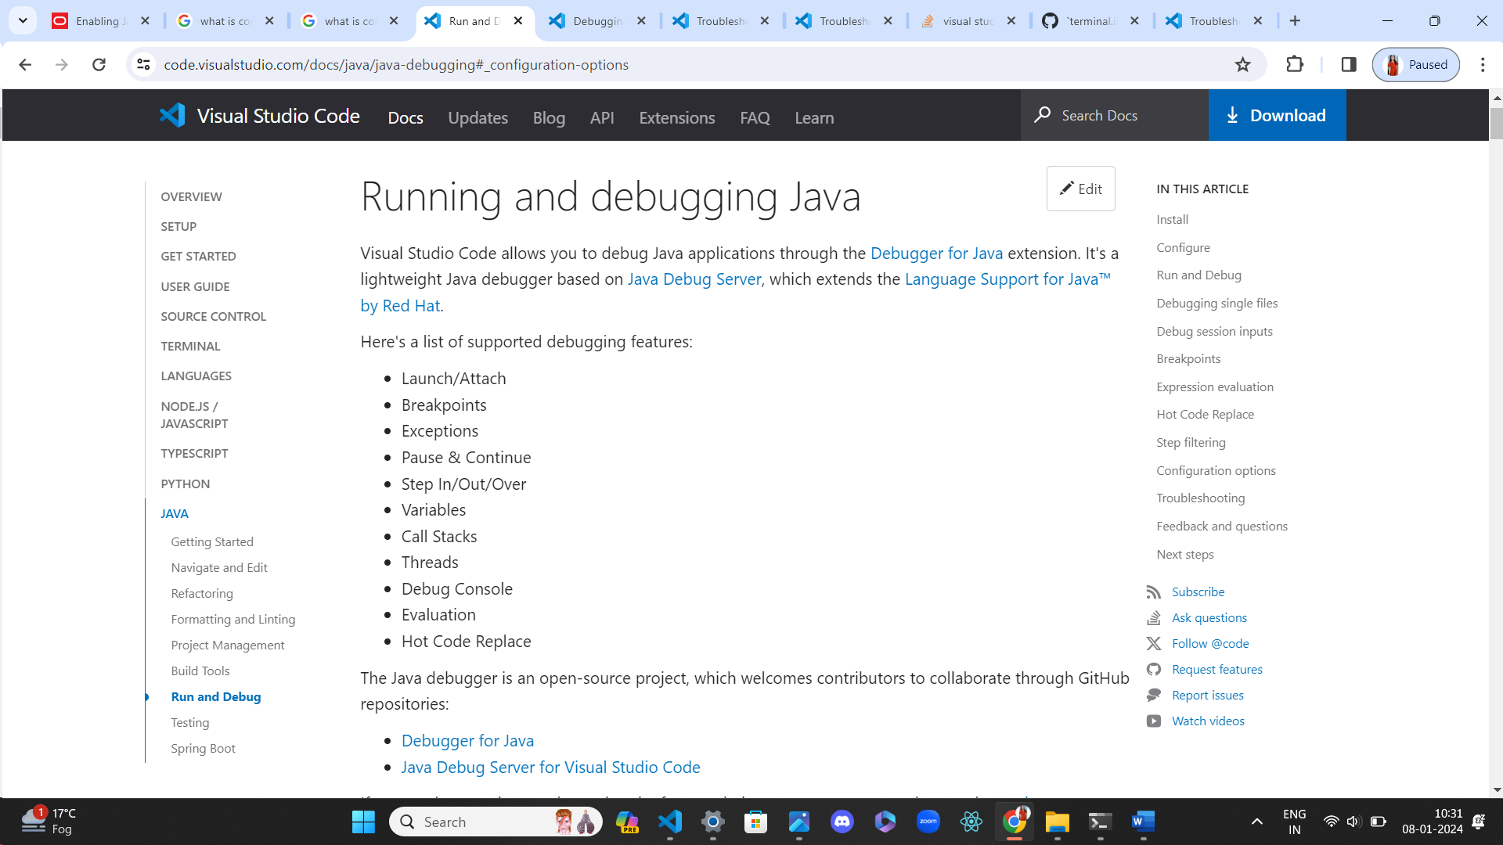

So after clicking open help button it open vs studio online community page



And it open and suggested to work with vs studio setting on the “terminal.integrated shell:”

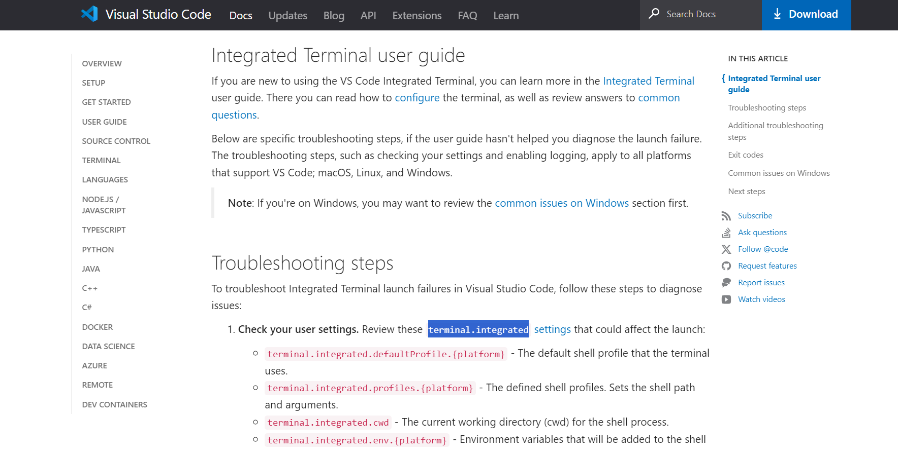

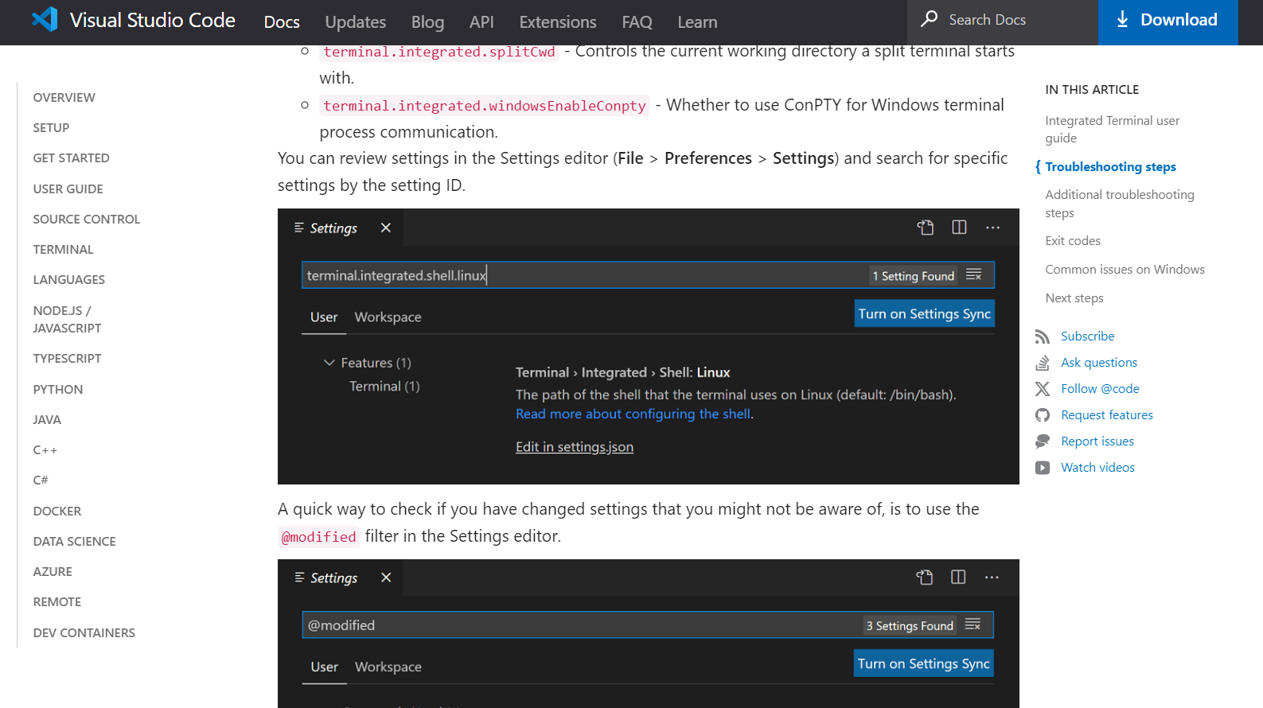

So I try to follow the step and I type in setting “terminal.integrated shell:”

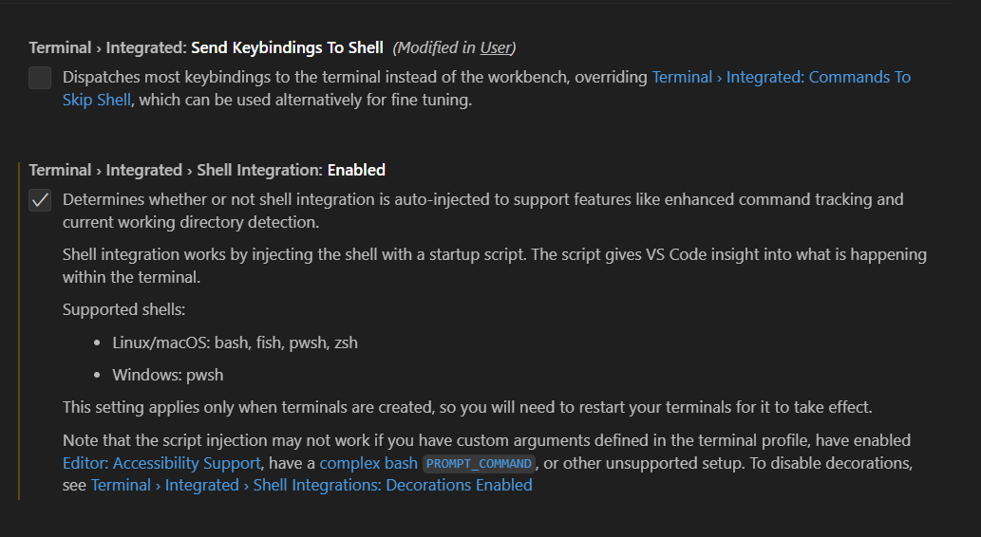

So I unchecked the first option which was already checked in previous project work

And I check the second option

And after that as we know until now we set the right path of bin in json file and after solvinf that error one error was left to debut it all start working without using the cmd line option to run the file you can see in below picture.

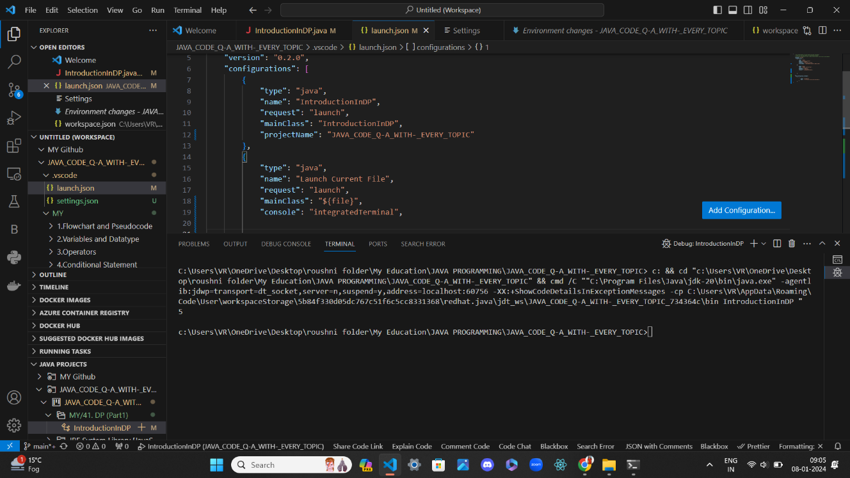

Now look JAVA PROGRAMMING PROJECT configure java runtime after all setting was set up

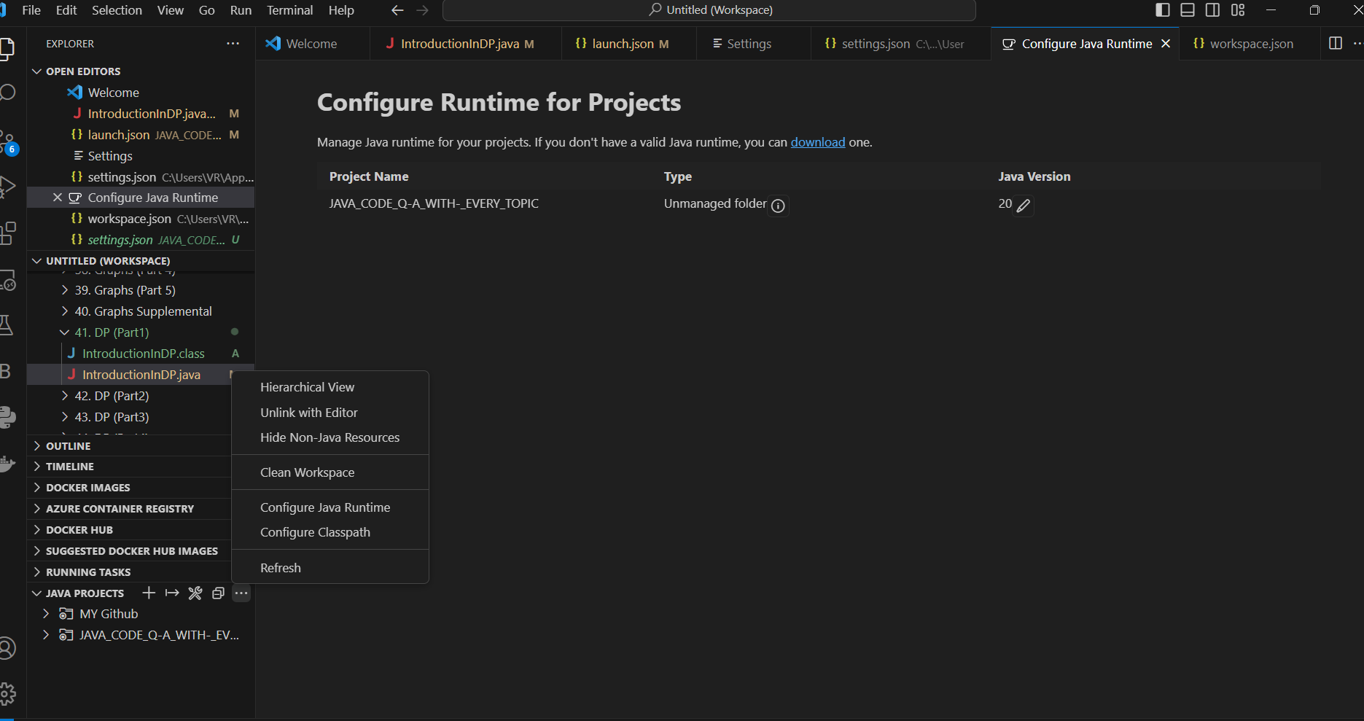

Now see java project “JAVA PROGRAMMING” configure class path

